AngularForms Two Way Data Binding

Angular 2 can also design forms which can use two-way binding using the **ngModel** directive. Let’s see how we can achieve this.

**Step 1** − Create a model which is a products model. Create a file called **products.ts** file.

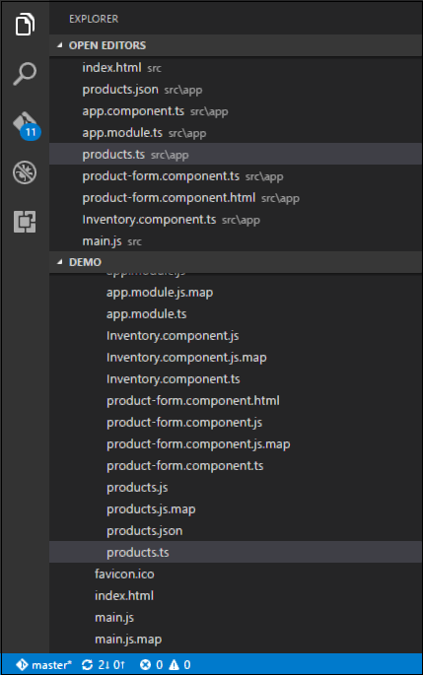

**Step 2** − Place the following code in the file.

export class Product {

constructor (

public productid: number,

public productname: string

) { }

}

This is a simple class which has 2 properties, productid and productname.

**Step 3** − Create a product form component called product-form.component.ts component and add the following code −

import { Component } from '@angular/core';

import { Product } from './products';

@Component ({

selector: 'product-form',

templateUrl: './product-form.component.html'

})

export class ProductFormComponent {

model = new Product(1,'ProductA');

}

The following points need to be noted about the above program.

* Create an object of the Product class and add values to the productid and productname.
* Use the templateUrl to specify the location of our product-form.component.html which will render the component.

**Step 4** − Create the actual form. Create a file called product-form.component.html and place the following code.

<div class = "container">

<h1>Product Form</h1>

<form>

<div class = "form-group">

<label for = "productid">ID</label>

<input type = "text" class = "form-control" id = "productid" required

[(ngModel)] = "model.productid" name = "id">

</div>

<div class = "form-group">

<label for = "name">Name</label>

<input type = "text" class = "form-control" id = "name"

[(ngModel)] = "model.productname" name = "name">

</div>

</form>

<div>

Product ID: {{model.productid}}

</div>

<div>

Product Name: {{model.productname}}

</div>

</div>

The following point needs to be noted about the above program.

* The **ngModel** directive is used to bind the object of the product to the separate elements on the form.

**Step 5** − Place the following code in the app.component.ts file.

import { Component } from '@angular/core';

@Component ({

selector: 'my-app',

template: '<product-form></product-form>'

})

export class AppComponent { }

**Step 6** − Place the below code in the app.module.ts file

import { NgModule } from '@angular/core';

import { BrowserModule } from '@angular/platform-browser';

import { AppComponent } from './app.component';

import { FormsModule } from '@angular/forms';

import { ProductFormComponent } from './product-form.component';

@NgModule ({

imports: [ BrowserModule,FormsModule],

declarations: [ AppComponent,ProductFormComponent],

bootstrap: [ AppComponent ]

})

export class AppModule { }

**Step 7** − Save all the code and run the application using npm. Go to your browser, you will see the following output.

